**3.Git-HOL**

**PART 1: Branching**

**Step 1: Create a New Branch**

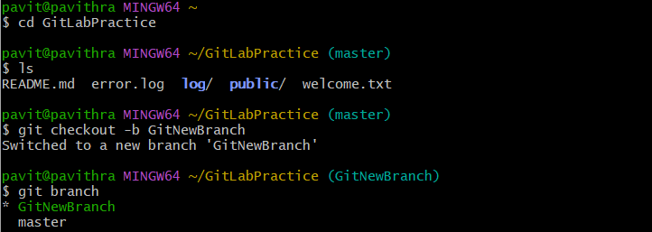

**Step 2: Verify Branches**



**Step 3: Add Files to New Branch**

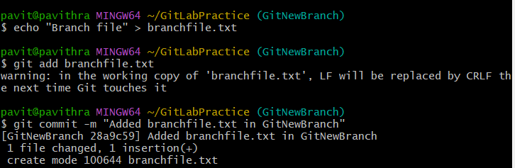

**Step 4: Check Git Status**



**PART 2: Merging**

**Step 5: Switch Back to Master**



**Step 6: View CLI Differences (between master & branch)**



**Step 7: Set Up P4Merge (only once)**

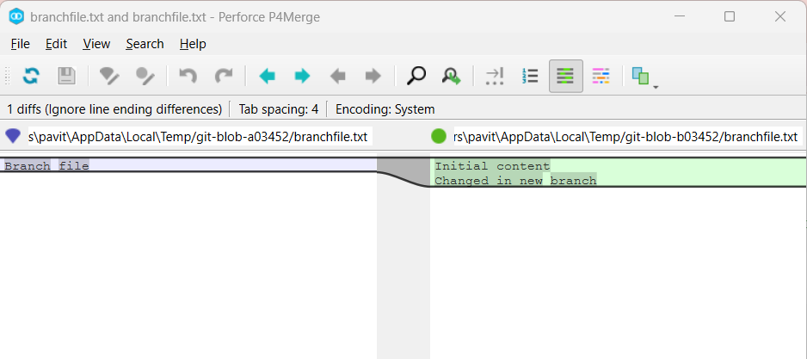

**Step 8:Merge the source branch to the trunk**



**Step 9:Observe the logging after merging using git log --oneline --graph --decorate**

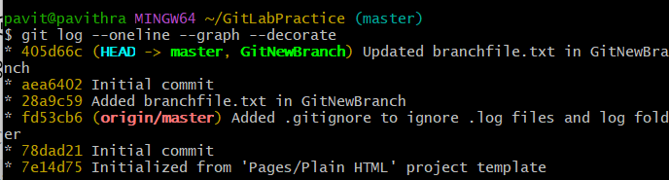

**Step 10:Delete the branch after merging with the trunk and observe the git status**

